**SQL Exercise 1**

1.Create the table SEMP with the following structure:-

2. Create the table SDEPT with the following structure:-

3. Insert into the SDEPT table the following values:- 10, Development 20, Training

4. Insert into the SEMP table the following values:- 0001, SUNIL, 6000, 10 0002, HIREN, 8000, 20 0003, ALI, 4000, 10, 0001 0004, GEORGE, 6000, 0002

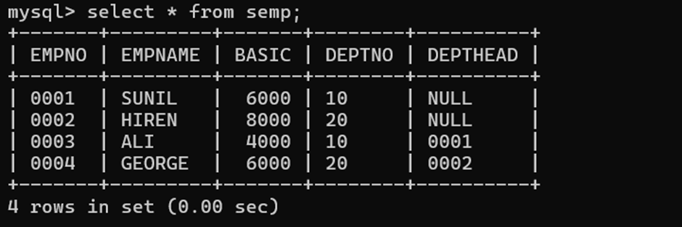

Create S, P, J, SPJ tables as specified below and insert a few rows in each table:- SUPPLIER (S#, Sname, Status, City) - S PARTS (P#, Pname, Color, Weight, City) - P PROJECTS (J#, Jname, City) - J SUPPLIER-PARTS-PROJECT (S#, P#, J#, Qty) - SPJ Sample data for S# column:- ‘S1’, ‘S2’, ‘S3’, etc. Sample data for P# column:- ‘P1’, ‘P2’, ‘P3’, etc. Sample data for J# column:- ‘J1’, ‘J2’, ‘J3’, etc. Sample data for Status column:- 10, 20, 30, etc. Write the SELECT queries to do the following:-

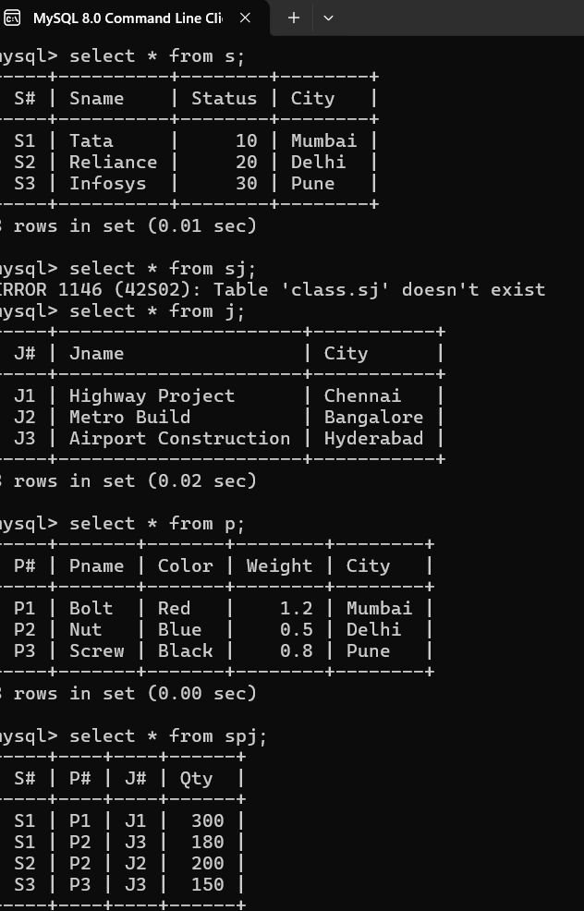

5. Display all the data from the S table.

6. Display only the S# and SNAME fields from the S table.

7. Display the PNAME and COLOR from the P table for the CITY=”Mumbai”.

8. Display all the Suppliers from Delhi.

9. Display all the Suppliers from Paris or Athens.

10. Display all the Projects in Athens.

11. Display all the Partnames with the weight between 12 and 14 (inclusive of both).

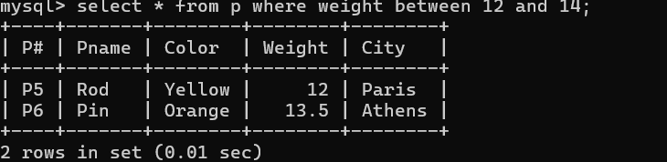

12. Display all the Suppliers with a Status greater than or equal to 20.

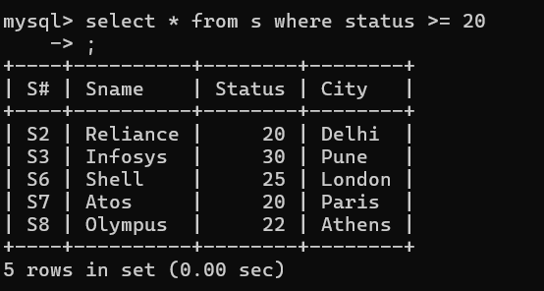

13. Display all the Suppliers except the Suppliers from London.

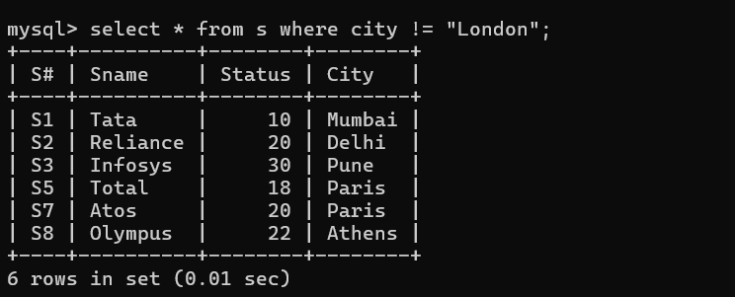

14. Display only the Cities from where the Suppliers come from.

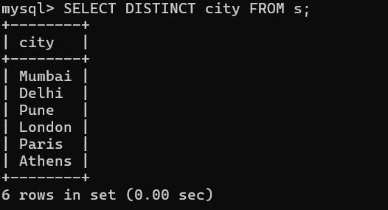

15. Assuming that the Part Weight is in GRAMS, display the same in MILLIGRAMS and KILOGRAMS.

